**Product Page Redesign**

**URL: https://www.espares.co.uk/product/es1566874/espares-washing-machine-and-dishwasher-cleane?vwo_opt_out=1**

1. **Product Image & CTA Section:**

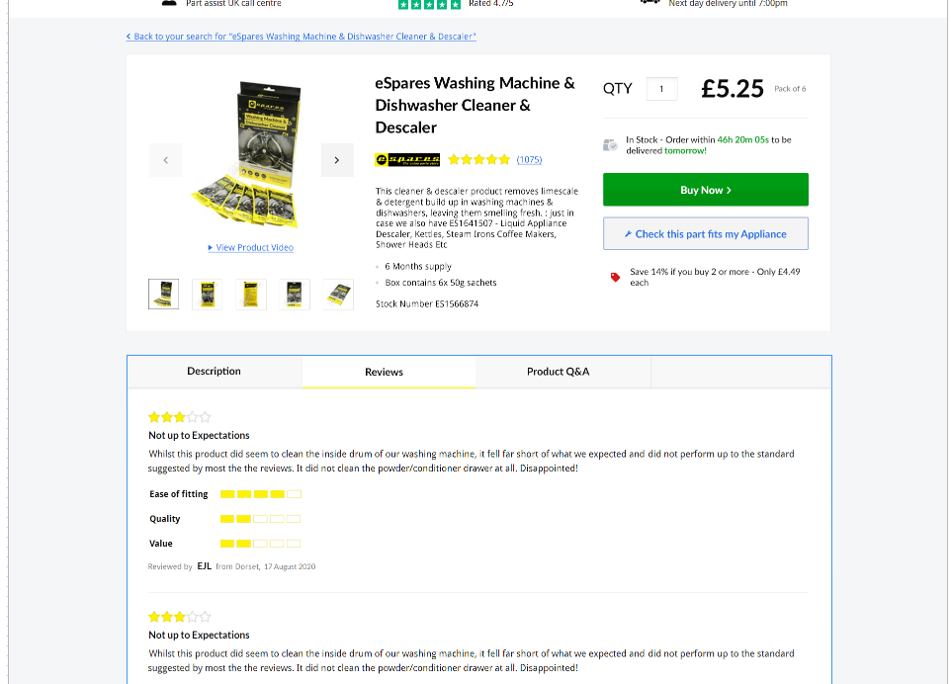

1. **Layout of the page will be like that of the variation.**
2. **Description, Reviews & Product Q&A will be in a tabbed structure. Clicking each tab will open the corresponding section.**
3. **Clicking the amount of reviews will open the reviews tab below and scroll down so that the first review is on top of the screen.**
4. **The ‘Order within…’ timer will remain hidden from Friday-Sunday but is present in the HTML.**
5. **URL of the Dyson Logo:** [**https://www.buyspares.co.uk/images/logos2/75/dyson.jpg**](https://www.buyspares.co.uk/images/logos2/75/dyson.jpg)

**(Logo in the images can be replaced with the above logo)**

1. **Carousel beneath the image will slide right by one thumbnail when clicked on right chevron or the rightmost visible thumbnail.** **Same goes for left chevron and left thumbnail. If carousel reaches leftmost position, left chevron will get hidden and same goes for the right chevron and rightmost position.**
2. **Clicking on ‘View Product Video’ will open the description tab and scroll down to ‘How to Videos’ section.**
3. **‘Will this Part Fit My Appliance?’ Section**

**URL:** [**https://www.espares.co.uk/product/es540297/bag255-compatible-u59-vacuum-cleaner-dust-bag?vwo_opt_out=1**](https://www.espares.co.uk/product/es540297/bag255-compatible-u59-vacuum-cleaner-dust-bag?vwo_opt_out=1)

**(Above designs should be compatible with this page as well)**

**Control:**

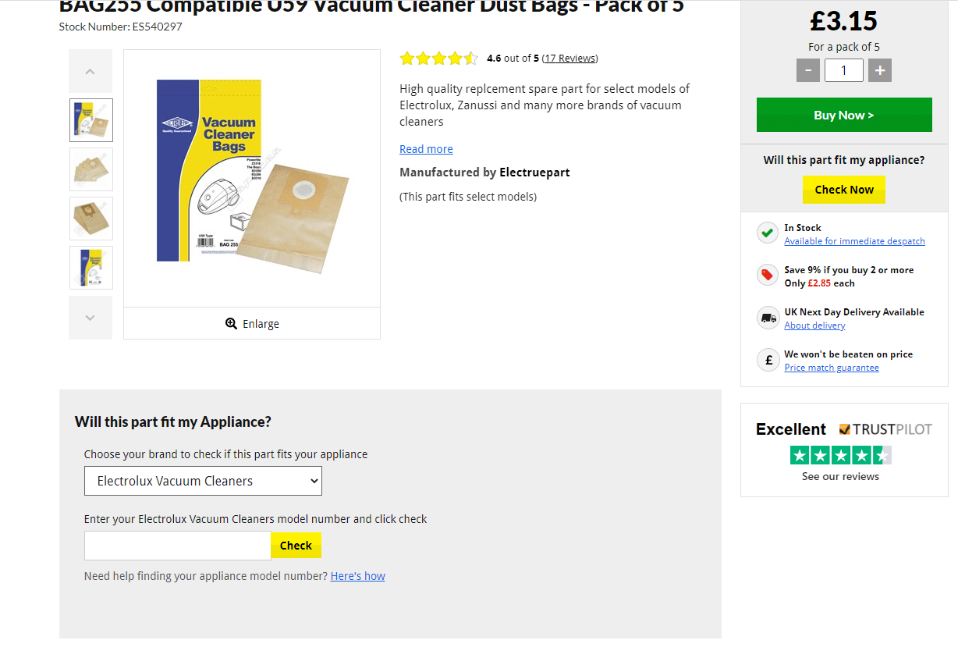

**Variation:**

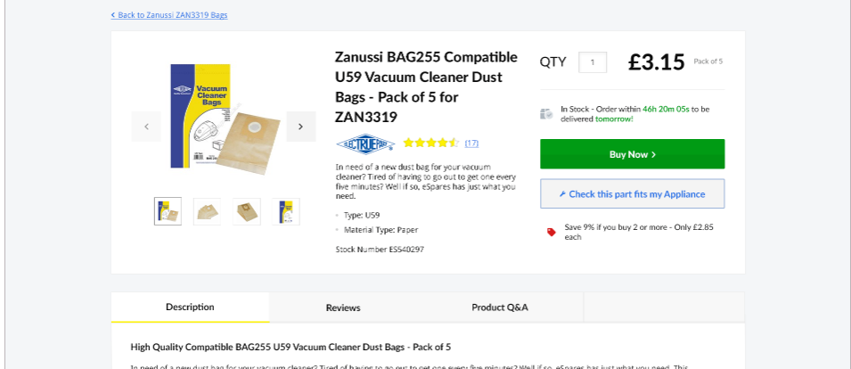

1. **Clicking on ‘Check this Part fits my Appliance’ will open the modelfit section which will be in a modal.**

**Control:**



**Variation:**

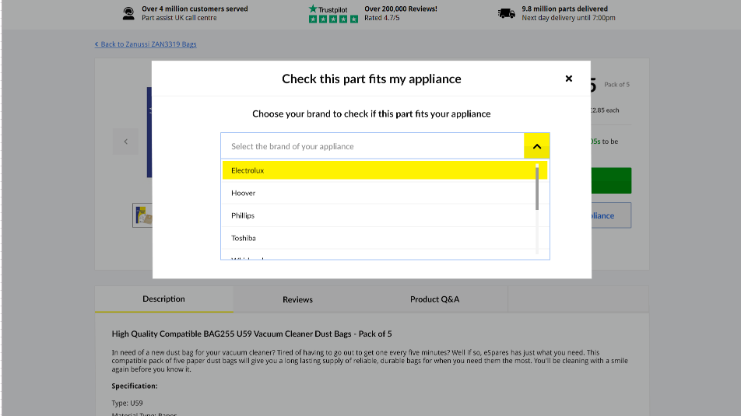

1. **The User will first get an option to select the brand**

**Control:**

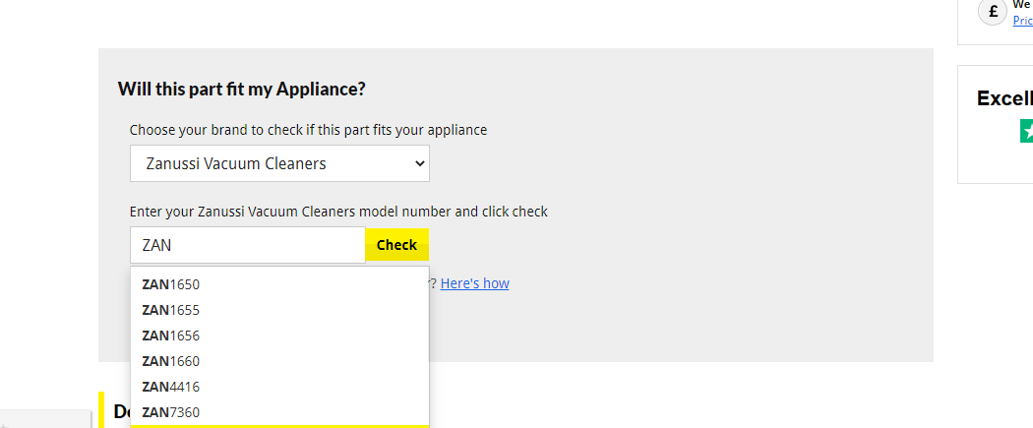

**Variation:**

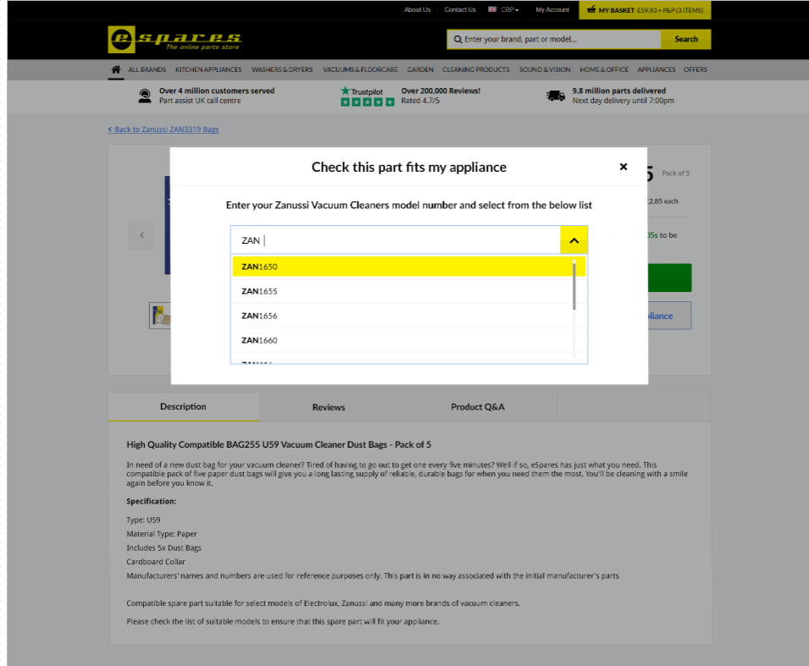

1. **After selecting the brand, the Heading message will change from ‘Choose your brand..’ to ‘Enter your Zanussi…’.**
2. **The user will then get the input box to type the model number. Typing in model number will display suggestion like control and the matching text of the suggestion will be bold.**

**Control:**

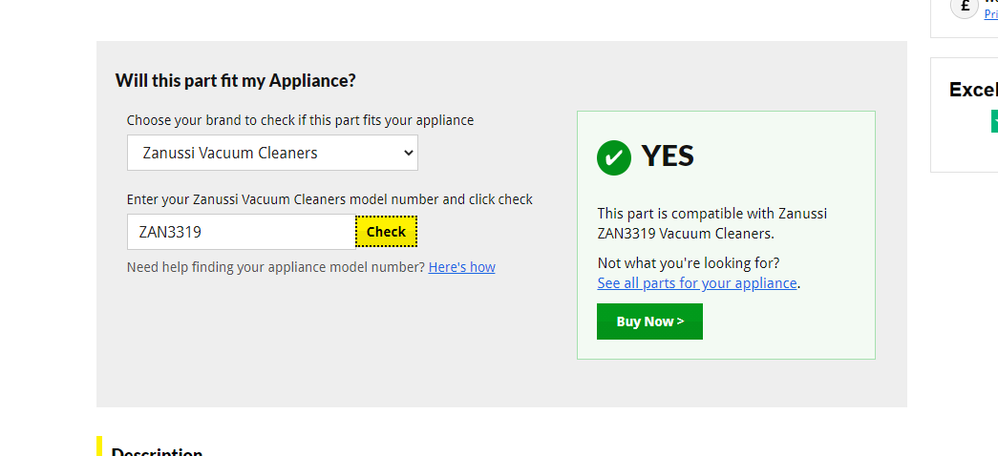

**Variation:**

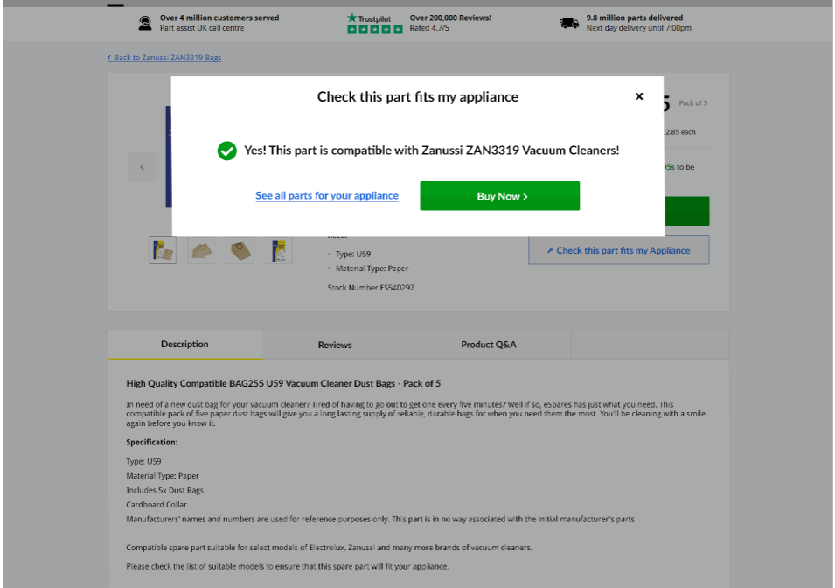

1. **After selecting a compatible model, the above message will displayed. The links of buttons will be same as that of control.**

**Control:**

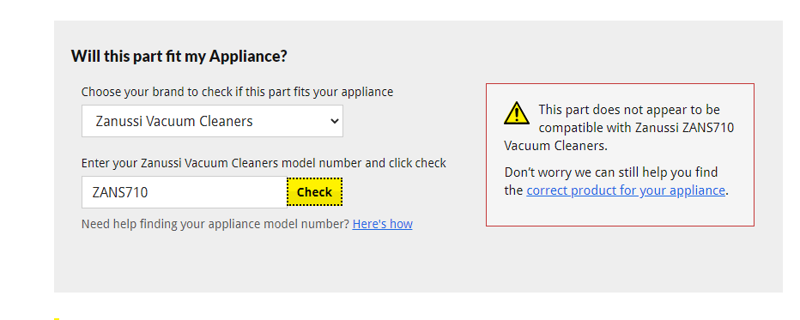

**Variation:**

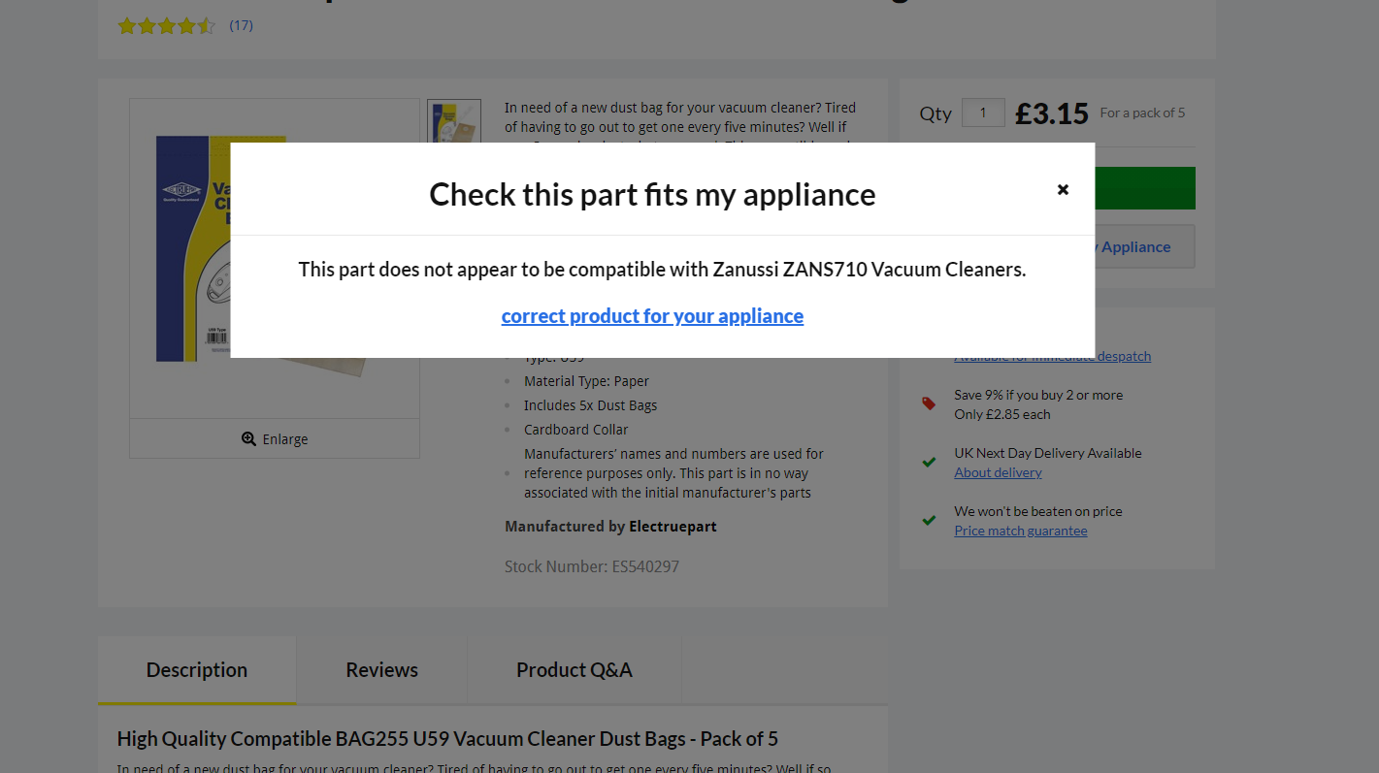

1. **If a user selects incompatible model, the above message will be displayed. The links of buttons will be same as that of control.**